Lesson 3 Homework | LT 5.2 | 3-11, 15, 16, 33 (a & b only)

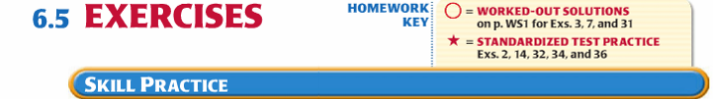

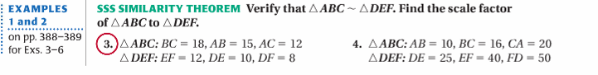

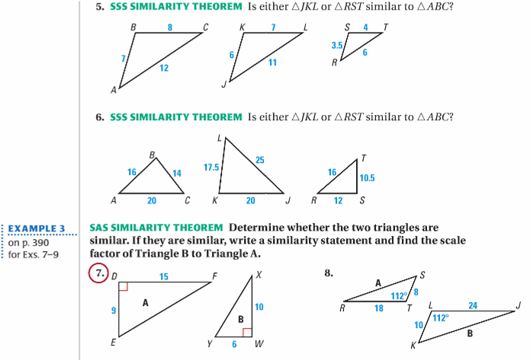

Lesson 3 Homework | LT 5.2 | 3-11, 15, 16, 33 (a & b only)

